Final Exam
Ryan Dreifuerst
Problems
- PS5 #6
- PS 7 #4
- BS 10-3
- PS8 #1
- PS8 II
- PS8 III
- PS8 IV

1). Truth model KF with Monte Carlo

function [xhist,zhist] = mcltisim(F,Gamma,H,Q,R,xbar0,P0,kmax)
% ltisim : Monte-Carlo simulation of a linear time invariant system.
%
% Performs a truth-model Monte-Carlo simulation for the discrete-time
% stochastic system model:
%
% x(k+1) = F*x(k) + Gamma*v(k)
% z(k) = H*x(k) + w(k)
%
% Where v(k) and w(k) are uncorrelated, zero-mean, white-noise Gaussian random
% processes with covariances E[v(k)*v(k)?] = Q and E[w(k)*w(k)?] = R. The
% simulation starts from an initial x(0) that is drawn from a Gaussian
% distribution with mean xbar0 and covariance P0. The simulation starts at
% time k = 0 and runs until time k = kmax.
%
%
% INPUTS
%
% F ----------- nx-by-nx state transition matrix
%
% Gamma ------- nx-by-nv process noise gain matrix
%
% H ----------- nz-by-nx measurement sensitivity matrix
%
% Q ----------- nv-by-nv symmetric positive definite process noise covariance
% matrix.
%
% R ----------- nz-by-nz symmetric positive definite measurement noise
% covariance matrix.
%
% xbar0 ------- nx-by-1 mean of probability distribution for initial state
%
% P0 ---------- nx-by-nx symmetric positive definite covariance matrix
% associated with the probability distribution of the initial
% state.
%
% kmax -------- Maximum discrete-time index of the simulation
%
%
% OUTPUTS
%
% xhist ------- (kmax+1)-by-nx matrix whose kth row is equal to x(k-1)?. Thus,
% xhist = [x(0), x(1), ..., x(kmax)]?.
%
% zhist ------- kmax-by-nz matrix whose kth row is equal to z(k)?. Thus, zhist
% = [z(1), z(2), ..., z(kmax)]. Note that the state vector
% xhist(k+1,:)? and the measurement vector zhist(k,:)?
% correspond to the same time.
%
%+------------------------------------------------------------------------------+
% References: Estimation Theory notes from Todd Humphreys
%
%
% Author: Ryan Dreifuerst
%+==============================================================================+
% First of all, that is such a long docstring....

[nz, nx] = size(H);
[nv, ~] = size(Q);
xhist = zeros(kmax+1, nx);
zhist = zeros(kmax, nz);

% Generate the truth sample
xhist(1, :) = randn(1, nx)*chol(P0)+xbar0';
% Generate noise
w = randn(kmax, nz)*chol(R);
v = randn(kmax, nv)*chol(Q);

% H*xhist(1, :)' + w(1)'
% Iterate the data
plot(v)
for k=1:kmax
xhist(k+1, :) = F*xhist(k, :)' + Gamma*v(k)';
zhist(k, :) = H*xhist(k+1, :)' + w(k)';
end

% Problem set 5 #6
% Develop a truth model MC simulation
clear all;
close all;

format short

% 5000 is used for the expectation case
maxMC = 5000;

MC = [50, 1000, maxMC];
kmax = 50;
time10 = 10;
time35 = 35;
% load the basic params from Q3
kf_example02a
clear zhist
rng(0);

xhat = zeros(51, 2);
xhat(1, :) = xhat0;
P = zeros(51, 2, 2);
P(1, :, :) = P0;
xtilde = zeros(50, 2);
epsilon = zeros(3, 50, 1);
xplots = zeros(1000, 50, 2);

%% Run Monte Carlos
for sets=1:3
for sim=1:MC(sets)
[xhist, zhist] = mcltisim(Fk, Gammak, Hk, Qk, Rk, xhat0, P0, kmax);
xhat(1, :) = xhat0;
P(1, :, :) = P0;
%% Begin Filter
for k=1:kmax
%% State and Cov. Prop
xbar = Fk*xhat(k, :)';
Pbar = Fk*squeeze(P(k, :, :))*Fk' + Gammak*Qk*Gammak';
%% Measurement Update
nu = zhist(k) - Hk*xbar;
s = Hk*Pbar*Hk' + Rk;
W = Pbar*Hk'*s^-1;
xhat(k+1, :) = xbar + W*nu;
P(k+1, :, :) = Pbar - W*s*W';
xtilde(k, :) = xhist(k+1, :) - xhat(k+1, :);
% need to scale the epsilons by the number of MC run
epsilon(sets, k) = (xtilde(k, :)*squeeze(P(k, :, :)) * xtilde(k, :)')./MC(sets);
end
xplots(sim, :, :) = xtilde(:, :);
xplots(sim, :, :) = xtilde(:, :);
end
disp(['MC=' num2str(MC(sets))]);

disp(['E[xtilde(10)]=']);
Extilde10 = mean(squeeze(xplots(:, time10, :)))

disp(["E[xtilde(10)*xtilde'(10)]="])
cov10 = cov(squeeze(xplots(:, time10, :)))
disp("compare with P(10)")
P10 = squeeze(P(time10+1, :, :))

disp(['Extilde(35)]=']);
Extilde35 = mean(squeeze(xplots(:, time35, :)))
disp(["E[xtilde(35)*xtilde'(35)]="]);
cov35 = cov(squeeze(xplots(:, time35, :)))
disp("compare with P(35)")
P35 = squeeze(P(time35+1, :, :))
end

figure
plot(1:kmax, xtilde)
title("Xtilde")
%
% Extilde10 = mean(squeeze(xplots(:, time10, :)))
% Extilde35 = mean(squeeze(xplots(:, time35, :)))
%
% cov10 = cov(squeeze(xplots(:, time10, :)))
% disp("compare with P(10)")
% P10 = squeeze(P(time10+1, :, :))
%
% cov35 = cov(squeeze(xplots(:, time35, :)))
% disp("compare with P(35)")
% P35 = squeeze(P(time35+1, :, :))

sims = 1:maxMC;
figure

ave10 = zeros(maxMC, 2);
ave35 = zeros(maxMC, 2);
for i=1:maxMC
ave10(i, :) = mean(squeeze(xplots(1:i, time10, :)));
ave35(i, :) = mean(squeeze(xplots(1:i, time35, :)));
end

plot(sims, ave10)
title("Xtilde(10) average versus monte carlo runs");

figure
plot(sims, ave35)
title("Xtilde(35) average versus monte carlo runs");

*** Results are summarized in a table at the end of the printed results ***

MC=50
E[xtilde(10)]=

Extilde10 =

1.0e-03 *

0.0509 0.6722

E[xtilde(10)*xtilde'(10)]=

cov10 =

0.0000 0.0000
0.0000 0.0019

compare with P(10)

P10 =

0.0005 0.0003
0.0003 0.0311

Extilde(35)]=

Extilde35 =

1.0e-03 *

0.0735 -0.3629

E[xtilde(35)*xtilde'(35)]=

cov35 =

0.0000 -0.0000
-0.0000 0.0012

compare with P(35)

P35 =

0.0005 0.0003
0.0003 0.0311

MC=1000
E[xtilde(10)]=

Extilde10 =

0.0007 0.0082

E[xtilde(10)*xtilde'(10)]=

cov10 =

0.0005 0.0004
0.0004 0.0317

compare with P(10)

P10 =

0.0005 0.0003
0.0003 0.0311

Extilde(35)]=

Extilde35 =

1.0e-03 *

-0.5194 -0.3799

E[xtilde(35)*xtilde'(35)]=

cov35 =

0.0005 0.0003
0.0003 0.0315

compare with P(35)

P35 =

0.0005 0.0003
0.0003 0.0311

MC=5000
E[xtilde(10)]=

Extilde10 =

-0.0003 -0.0035

E[xtilde(10)*xtilde'(10)]=

cov10 =

0.0005 0.0002
0.0002 0.0313

compare with P(10)

P10 =

0.0005 0.0003
0.0003 0.0311

Extilde(35)]=

Extilde35 =

0.0000 0.0013

E[xtilde(35)*xtilde'(35)]=

cov35 =

0.0005 0.0002
0.0002 0.0313

compare with P(35)

P35 =

0.0005 0.0003
0.0003 0.0311

MC Runs | E[x ̃(10)] | E[x ̃(10)x ̃T (10)] | E[x ̃(35)] | E[x ̃(35)x ̃T (35)]
50 | 1.0e-03 *  [ 0.0509 0.6722] | 0.0000 0.0000  0.0000 0.0019 | 1.0e-03 *  0.0735 -0.3629 | 0.0000 -0.0000  -0.0000 0.0012
1000 | [0.0007 0.0082] | 0.0005 0.0004  0.0004 0.0317 | 1.0e-03 *  [-0.5194 -0.3799] | 0.0005 0.0003  0.0003 0.0315
5000 | [-0.0003 -0.0035] | 0.0005 0.0002  0.0002 0.0313 | [0.0000 0.0013] | 0.0005 0.0002  0.0002 0.0313
Desired result | [0 0] | 0.0005 0.0003  0.0003 0.0311 | [0 0] | 0.0005 0.0003  0.0003 0.0311

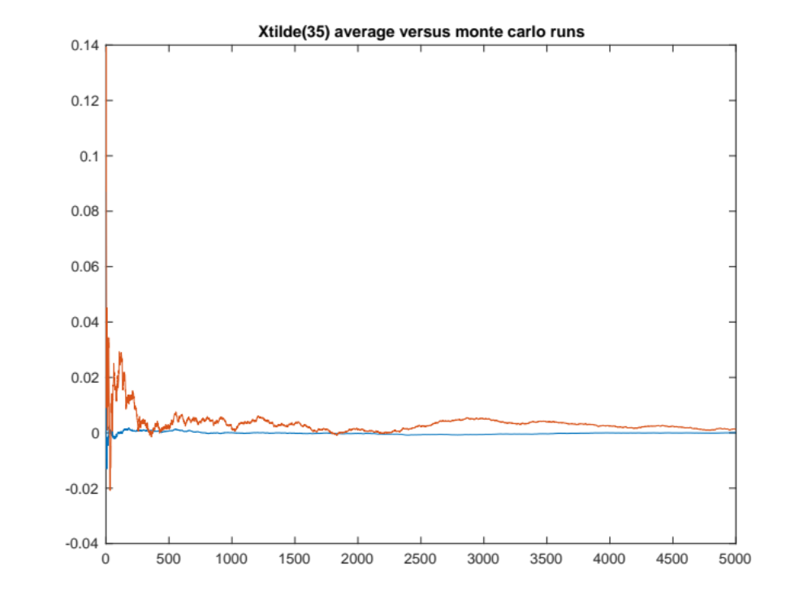

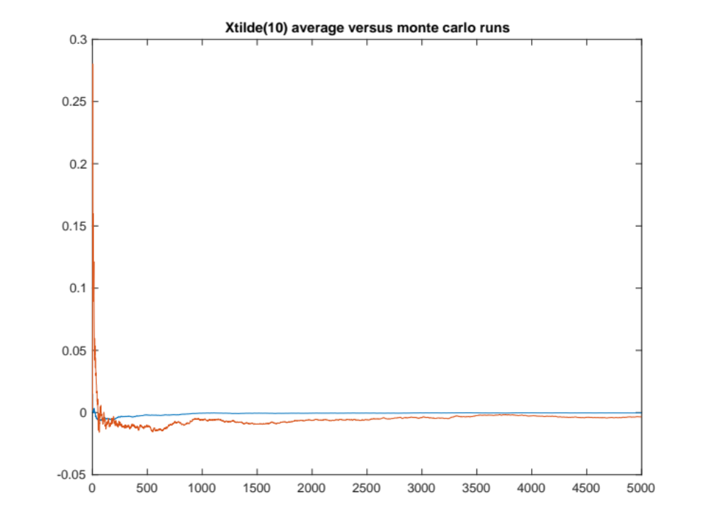
It is clear that the expected value of the errors approaches zero as the number of runs increases, simply by looking at the graph. Also, the table shows how the error covariances after only 50 simulations is not very effective, but after 1000 or 5000, it is nearly identical to the corresponding P(k) value.

2). See inserted next page for SRI-(I)EFK

3). B.S. 10-3 polar to Cartesian

3.1) Find the transformation y=h⁻¹(z) = [x1 x2]^{T} + wc
y = [z1*cos(z2); z1*sin(z2)]
3.2) Find the covariance matrix Rc of wv using linearization at P = 10^5, theta = 45
rbar = 10^5;
thetabar = 45/180*pi; % convert to radians

% linearize
zbar = [rbar; thetabar];
dxdr = cos(thetabar);
dxdtheta = -rbar*sin(thetabar);
dydr = sin(thetabar);
dydtheta = rbar*cos(thetabar);

sigmap = 100;
sigmatheta = 0.5/180*pi;
Pzz = [sigmap^2, 0; 0, sigmatheta^2];
H = [dxdr, dxdtheta; dydr, dydtheta];

ybar = [rbar*cos(thetabar); rbar*sin(thetabar)]

Rc = H*Pzz*H'
Rc =

1.0e+05 *

3.8577 -3.7577
-3.7577 3.8577

3.3) Simulate and solve for the cartesian positions and the average of y
function [x] = GaussGen(xbar,Pxx, nx, n)
% Generate nx, n gaussians with Pxx and xbar
A = chol(Pxx)';
x = A*randn(nx, n) + xbar;

N = 10000;
nx = 2;
R = diag([100^2, (0.5/180*pi)^2]);
w = GaussGen(0, R, nx, N);
z = zbar + w;
y = zeros(nx, N);
for i=1:N
y(:, i) = [z(1, i)*cos(z(2, i)); z(1, i)*sin(z(2, i))];
end
y_avg = mean(y, 2)
y_avg =

1.0e+04 *
[7.0707, 7.0711]’

3.4) Analyze whether Wc are zero mean
Wcmean = mean(y-ybar, 2)
Wcmean =

-3.7512
0.7321
So it appears that they are not zero mean, and in fact there is variance to the mean, so each repetition gives different results. It is not zero mean due to the non-linear function of h and where it is linearized about, which is zbar.

3.5) Analyze whether the covariance matrix from previously is acceptable
cov_test = zeros(nx, nx);
cov_test = cov(y')

cov_test =

1.0e+05 *

3.8861 -3.7917
-3.7917 3.9002

So cov_test is very close to Rc, and thus the linearization is acceptable for calculating the covariance matrix, even though the error, Wc, is not zero mean.
4)PS8 #1
% Multiple-model estimation example: The solar panel deployment problem
% User defined
clear all;
close all;

sims = 400;
xtilde = zeros(sims, 1000, 2);
plotloc = [400, 400, 1800, 1300];

mincost = 47.4;
ideal = 0.42378;
format long;

% load provided data
load('mmExampleModeSwitchingData.mat')

% uncomment to test consistency over a range
% for lowerbound=0.4237:0.00002:0.439
zero_mean = 0;
lower_bound = ideal;
switching = 2;
switchtime = 20;
transition = 0;

%----- Simulation parameters
dt = 0.1;
Nsim = 1000;
% tkhist = [0:Nsim-1]'*dt;
% nmod is the number of models considered
nmod = 3;
nx = 2;
nz = 1;
nu = 1;

%----- Random number seed
% n_seed = round(sum(clock*100));
% For reproducible results
n_seed = 1;
randn('state', n_seed);

for expectationrun=1:sims
%----- Storage matrices
% xtruekhist = zeros(Nsim,nx);
% ztruekhist = zeros(Nsim,nz);
xhatkhist = zeros(Nsim,nx);
Pkhist = zeros(Nsim,nx);
% xhatkMhist is an array of all the mode-conditioned estimates
xhatkMhist = zeros(Nsim,nx,nmod);
PkMhist = zeros(Nsim,nx,nx,nmod);
mukhist = zeros(Nsim,nmod);
nukMhist = zeros(Nsim,nz,nmod);
LambdakMhist = zeros(Nsim,nmod);
FkM = zeros(nx,nx,nmod);
GkM = zeros(nx,nu,nmod);
invSkMhist = zeros(Nsim, nmod);

%----- Set up multiple system models
cSet = [0.1;0.5;1]; hzSet = [1;2;3];
avec = cSet./hzSet;
bvec = 1./hzSet;
for j=1:nmod
a = avec(j);
b = bvec(j);
Amat = [0, 1; 0, -a];
% Discrete-time state transition matrix
% FkM(:,:,j) = Amat*dt+eye(nx, nx);
FkM(:, :, j) = expm(Amat*dt);
% Discrete-time control matrix
GkM(:,:,j) = [b/a^2*(exp(-a*dt) + a*dt - 1); -(b/a*(exp(-a*dt) - 1))];
end

%----- Truth model
% switchHist gives the model switching time history and switchIndex gives
% the indices at and after which each model obtains. For the static case,
% switchHist is either 1, 2, or 3, and switchIndex = 1;
if switching == 1
switchHist = randi([1, 3], 1, Nsim*dt/switchtime);
switchIndex = 1:switchtime/dt:Nsim;
% Normally I would randomly assign states
% but since it impacts the dynamics equations,
% a good estimate cannot be had without some knowlege of the dynamics
% at that time. So I attempt to determine them and encode them.
elseif switching == 2
switchHist = [1, 3, 1];
switchIndex = [1, 200, 800];
else
switchHist = [1];
switchIndex = [1];
end
Qk = 0.001*diag([0.1 1]); Rq = chol(Qk);
vtruekhist = (Rq'*randn(nx,Nsim))';
Rkp1 = 0.1; Rr = chol(Rkp1);
wtruekhist = (Rr'*randn(nz,Nsim))';
% utruekhist = 2*randn(Nsim,nu);
Hkp1 = [1 0];
x1 = [0;0.1];

%----- Generate truth-model states and measurements
xk = x1;
ii = 1;
for k=1:Nsim-1
if k==switchIndex(ii)
Fk = FkM(:,:,switchHist(ii));
Gk = GkM(:,:,switchHist(ii));
if ii<length(switchHist)
ii = ii+1;
end
end
kp1 = k + 1;
uk = utruekhist(k,:)';
vk = vtruekhist(k,:)';
wkp1 = wtruekhist(kp1,:)';
xkp1 = Fk*xk + Gk*uk + vk;
zkp1 = Hkp1*xkp1 + wkp1;
% xtruekhist(k,:) = xk';
% ztruekhist(kp1,:) = zkp1';
xk = xkp1;
end

%----- Run the Multiple-model filter
% Set up initial states and covariances
P1 = 10*eye(nx);
xhat1 = x1 + (chol(P1))'*randn(nx,1);
for j=1:nmod
PkMhist(1,:,:,j) = P1;
% Initialize the mode probabilities as equally probable
mukhist(1,j) = 1/nmod;
xhatkMhist(1,:,j) = xhat1';
end
for k=1:Nsim-1
kp1 = k + 1;
zkp1 = ztruekhist(kp1,:)';
uk = utruekhist(k,:)';
for j=1:nmod
% Propagation step
Fkj = FkM(:,:,j);
Gkj = GkM(:,:,j);
xhatkj = xhatkMhist(k,:,j)';
Pkj = squeeze(PkMhist(k,:,:,j));
xbarkp1j = Fkj*xhatkj + Gkj*uk;
Pbarkp1j = Fkj*Pkj*Fkj' + Qk;

% Measurement update
nukp1j = zkp1 - Hkp1*xbarkp1j;
Skp1j = Hkp1*Pbarkp1j*Hkp1' + Rkp1;
invSkp1j = inv(Skp1j);
Wkp1j = Pbarkp1j*Hkp1'*invSkp1j;
xhatkp1j = xbarkp1j + Wkp1j*nukp1j;
Pkp1j = Pbarkp1j - Wkp1j*Skp1j*Wkp1j';

% Calculate the likelihood of the current innovation
Lambdakp1j = normpdf(nukp1j, zero_mean, Skp1j);

% Store state estimate and covariance, innovation, and likelihood
xhatkMhist(kp1,:,j) = xhatkp1j';
PkMhist(kp1,:,:,j) = Pkp1j;
nukMhist(kp1,:,j) = nukp1j';
LambdakMhist(kp1,j) = Lambdakp1j;
% also store the inverse S for consistency testing
invSkMhist(kp1, j) = invSkp1j;
end

% Update the mode probabilities
mukvec = mukhist(k,:)';
Lambdakp1vec = LambdakMhist(kp1,:)';
% mukp1vec is the nmod-by-1 vector that contains the mode probabilities
% for the nmod modes at time index kp1; it must satisfy sum(mukp1vec) = 1.
mukp1vec = Lambdakp1vec.*mukvec./sum(Lambdakp1vec.*mukvec);

% Ad hoc adjustment
% assume low probability of switching given previous state due to
% frequentist approach
% most likely previous mode
if size(switchHist, 2) > 1
for anothervariable=1:nmod
if mukp1vec(anothervariable) < lower_bound
mukp1vec(anothervariable) = lower_bound;
end
end
if transition == 1
[largestmu, modesel] = max(mukhist(k, :));
pij = [1; 1; 1]/40;
pij(modesel) = 19/20;
mukvec = mukvec.*pij;
mukp1vec = Lambdakp1vec.*mukvec./sum(Lambdakp1vec.*mukvec);
end
% renormalize
mukp1vec = mukp1vec./(sum(mukp1vec));
end

mukhist(kp1,:) = mukp1vec';

% Calculate the combined state estimate and covariance
xMdum = reshape(squeeze(xhatkMhist(kp1,:,:)),nx,nmod);
mudum = mukhist(kp1,:)';
% Calculate the MMSE estimate averaged over all the modes
xhatkp1 = (xMdum*mudum);
% Calculate the estimation error covariance of xhatkp1
Pkp1 = zeros(nx,nx);
for j=1:nmod
Pkp1j = squeeze(PkMhist(kp1,:,:,j));
xhatkp1j = xhatkMhist(kp1,:,j)';
mukp1j = mukhist(kp1,j);
Pkp1 = Pkp1 + mukp1j*(Pkp1j + (xhatkp1j-xhatkp1)*(xhatkp1j-xhatkp1)');
end
xhatkhist(kp1,:) = xhatkp1';
Pkhist(kp1,:) = diag(Pkp1)';
end

xtilde(expectationrun, :, :) = xtruekhist - xhatkhist;
for thisstep=2:Nsim
ev(expectationrun, thisstep) = squeeze(xtilde(expectationrun, thisstep, :))'*inv(diag(squeeze(Pkhist(thisstep, :))))*squeeze(xtilde(expectationrun, thisstep, :));
end
% record the expectation for each time step, as more simulations are added
% to the averaging
meanev(expectationrun, :) = mean(ev(1:expectationrun, :), 1);
end

% determine how consistent the filter was
cost = abs(sum(meanev(end, :)-nx))
if cost < mincost
mincost = cost
ideal = lower_bound
bestev(:, :) = meanev(:, :);
end

% end
%%
%----- Display results
figure(1);clf;
plot(tkhist,mukhist);shg;
xlabel('Time (s)');
ylabel('Probability');
legend('\mu_1', '\mu_2','\mu_3');
title('Mode probability time histories');
set(gcf, 'position', plotloc);
ylim([0.1 0.8]);
xlim([0, max(tkhist)]);

figure(2);clf;
subplot(211)
iidum = 1:Nsim-1;
plot(tkhist(iidum), xtruekhist(iidum,1) - xhatkhist(iidum,1));
hold on;
plot(tkhist(iidum), sqrt(Pkhist(iidum,1)), 'k');
plot(tkhist(iidum), -sqrt(Pkhist(iidum,1)), 'k');
legend('Theta difference', 'Error Cov');
ylabel('\Delta \theta_z (rad)');
title('Estimation errors and covariances');
xlim([0, max(tkhist)]);
set(gcf, 'position', plotloc);

subplot(212)
iidum = 1:Nsim-1;
plot(tkhist(iidum), xtruekhist(iidum,2) - xhatkhist(iidum,2));
hold on;
plot(tkhist(iidum), sqrt(Pkhist(iidum,2)), 'k');
plot(tkhist(iidum), -sqrt(Pkhist(iidum,2)), 'k');
legend('Omega difference', 'Error Cov');
ylabel('\Delta \omega_z (rad/s)');
xlabel('Time (s)');
xlim([0, max(tkhist)]);
set(gcf, 'position', plotloc);

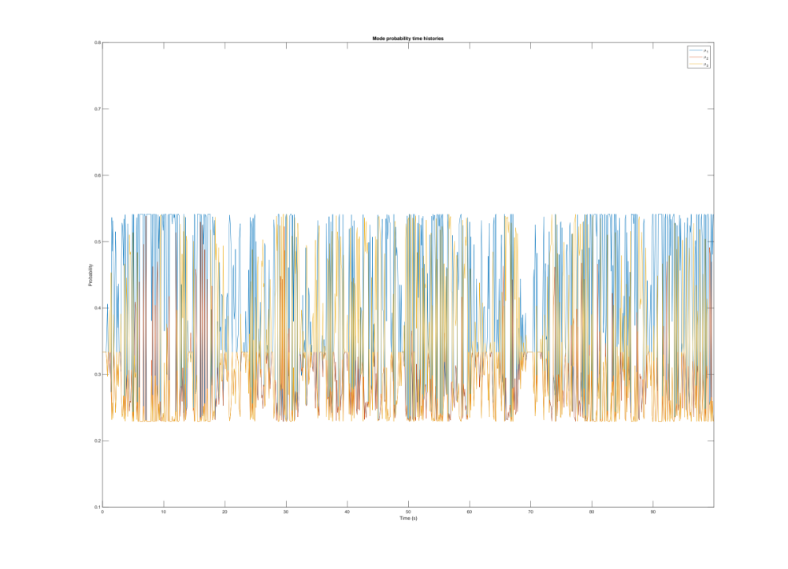
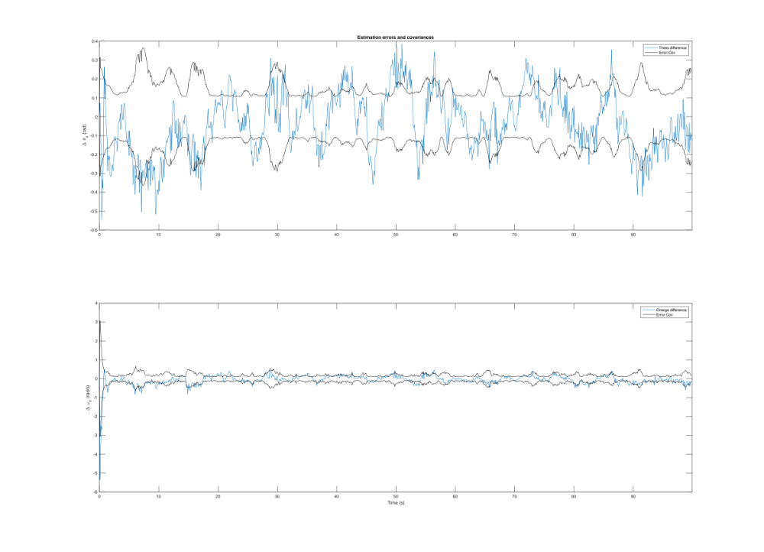
a) Multiple Model Filter Consistency
The filter is defined to be consistent based on statistical tests, for example it is expected that the x~^{T}*P⁻¹*x~ is distributed as a chi-squared with the number of simulations being the degrees of freedom. So, the lower bound can be tested to see which of the values results in the average approaching nx, since this is the expected value of the chi-squared test.
b) Algorithm for mumin
I propose the very simple grid search, where each point is tested with some degree of resolution, the highest consistency areas are found, and the process is repeated until a mumin is selected at a reasonable tradeoff between computational cost and accuracy. The test for consistency will just be the measure of the sum over all time steps of the difference in expectation of x~^{T}*P⁻¹*x~ and nx. The algorithm is implemented as the following:
- Initialize to some cost = 100
- Determine the testing bounds, in this case 0.01:0.01:0.99
- Run the filter for 400 simulations, recording the xtilde for each time.
- Calculate the E[x~^{T}*P⁻¹*x~] and subtract nx from each timestep and store the sum as the new_cost.
- If the new cost is lower than the previous cost, record the new ideal mu and cost
- Go back to step 3 with the next mu value.
- Extract the ideal value, set the new stepsize to 1/10 the old one, and set the new bounds to 10 steps up and down from the ideal value.
- If the new_cost is greater than cost by 1e-3, or some threshold, then go to step 2 with the new bounds.
- Otherwise stop, the ideal value is reached to reasonable accuracy versus computational complexity. For more precision, reduce the threshold and continue.

This is not a computationally efficient algorithm; however, it does maximize the consistency if infinite time/power/memory were used. It can be improved very easily with almost any other optimization algorithm, but this one minimizes design time at the cost of increasing computational expense. The cost function is clearly convex by watching the values from the grid search, so a convex solver would work. The time I spent resulted in an ideal mumin of 0.42378.

c) Factors for selecting mumin
The most important factors are recognizing that mumin cannot be large, as this would prevent the system from ever selecting a state, and would keep it just averaging the different models nearly equally. Anything greater than 1 would result in a completely even weighting, which would not perform well. Also, extremely small values are not useful since they will not really be able to provide much shifting of the state. In general, the model is more confident, although it could be completely wrong, when the mu value is set smaller. If the mode is going to switch more often, it is also advantageous to have a higher mu, since it would be more likely to switch states at a given moment. If the noise is very strong, it could be beneficial to reduce the mu since you do not want to switch due to a noisy sample. So, there are many factors which go into selecting the ideal mu.

d) What is the apparent mode history?
The estimator seems to generally start in state 1, then go to state 3, then return to state 1. So, the order, assuming about 20s per shift, is 1->3->3->3->1. This is not easily visible with the higher mumin, and in fact is more clear with a lower mumin, but this would fail to project the correct uncertainty in the estimated values. So lowering mumin c

e) What if the slipping was preferential?
Then implementing a transition probability vector would be useful. It could model the probability of transitioning, and be multiplied after the minimum was applied. Then there would be a tendency to avoid certain transitions in favor of more likely ones.

5) PS8 II – Unscented Transform
%% PS SPF #2
% Unscented Transform
% r = rbar + wr with sigmar
% theta = thetabar + wtheta with sigmatheta
% E[r; theta] = [rbar; thetabar]
% Cov = [sigmar^2, 0; 0, sigmatheta^2]

% transformation is
% x = r*cos(theta)
% y = r*sin(theta)
clear all;
close all;

nx = 2;
nz = 2;

set = 1;

if set==1
rbar = 76;
thetabar = -3*pi/180;
sigmar = 1;
sigmatheta = pi/180;
else
rbar = 76;
thetabar = -3*pi/180;
sigmar = 1;
sigmatheta = 15*pi/180;
end

% linearize about rbar and thetabar
xbar = [rbar; thetabar];
% zbar = h(xbar) + 1/2*H*Pxx*H'
dxdr = cos(thetabar);
dxdtheta = -rbar*sin(thetabar);
dydr = sin(thetabar);
dydtheta = rbar*cos(thetabar);

Pxx = [sigmar^2, 0; 0, sigmatheta^2];
H = [dxdr, dxdtheta; dydr, dydtheta];

zbar = [rbar*cos(thetabar); rbar*sin(thetabar)]
Pzz = H*Pxx*H'

%% Unscented Transform
alpha = 10^-3;
beta = 2;
kappa = 0;

chi(:, 1) = xbar;
lambda = alpha^2*(nx+kappa) - nx;
S = chol(Pxx)';

for i=2:nx+1
chi(:, i) = xbar + sqrt(nx+lambda)*S(:, i-1);
chi(:, i+nx) = xbar - sqrt(nx+lambda)*S(:, i-1);
end

scriptz = zeros(nz, 2*nx+1);
for j=1:2*nx+1
rj = chi(1, j);
thetaj = chi(2, j);
scriptz(:, j) = [rj*cos(thetaj); rj*sin(thetaj)];
end

zbar2 = lambda/(nx+lambda)*scriptz(:, 1);
for t=2:2*nx+1
zbar2 = zbar2 + 1/(2*(nx+lambda))*scriptz(:, t);
end

Pzz2 = (lambda/(nx+lambda)+1-alpha^2+beta)*(scriptz(:, 1)-zbar2)*(scriptz(:, 1)-zbar2)';
for t=2:2*nx+1
Pzz2 = Pzz2 + 1/(2*(nx+lambda))*(scriptz(:, t)-zbar2)*(scriptz(:, t)-zbar2)';
end

zbar2
Pzz2
% diff_zbar = zbar-zbar2
% diff_Pzz = Pzz-Pzz2

%% Generate vector and compare
ton = 1e6;

tonofXs = GaussGen(xbar, Pxx, nx, ton); % this is the same GaussGen as before

tonofZs = zeros(size(tonofXs));

for j=1:ton
rj = tonofXs(1, j);
thetaj = tonofXs(2, j);
tonofZs(:, j) = [rj*cos(thetaj); rj*sin(thetaj)];
end

samp_mean = zeros(nx, 1);
for j=1:ton
samp_mean = samp_mean + tonofZs(:, j);
end
samp_mean = samp_mean ./ ton

samp_cov = zeros(nx, nx);
for j=1:ton
samp_cov = samp_cov + tonofZs(:, j)*tonofZs(:, j)';
end

samp_cov = samp_cov./ton;
samp_cov = samp_cov - samp_mean*samp_mean'
Case 1:
zbar =

75.8958
-3.9775

Pzz =

1.0021 0.0397
0.0397 1.7574

zbar2 =

75.8843
-3.9769
Pzz2 =

1.0023 0.0397
0.0397 1.7574

samp_mean =

75.8841
-3.9775

samp_cov =

1.0002 0.0391
0.0391 1.7542

The results show that the linearized method and the unscented transform both produce good results compared to just calculating the actual sample mean and sample average. They seem to perform fairly similarly, with the unscented transform perhaps being a slight bit closer to the sampled values, but in this case either are very good estimators.

Case 2:
zbar =

75.8958
-3.9775

Pzz =
2.0816 20.6381
20.6381 394.7992

zbar2 =

73.2949
-3.8412

Pzz2 =
15.6111 19.9291
19.9291 394.8363

samp_mean =

73.3443
-3.8322

samp_cov =
14.5891 18.5905
18.5905 368.5053

In the noisier case, there is more distinction between the two estimation methods. The unscented transform is much more effective than the linearized version, which had a much smaller Pzz(1, 1) than the sampled method had. The linearized method also had a poorer estimate of the mean than the unscented transform, so we see that the unscented transform is perhaps more robust to noise than the linearization method is.

6) PS 8 III
%% PS SPF #3
clear all;
close all;
% xdot = s * cos(theta) + vx
% ydot = s * sin(theta) + vy
% sdot = vs
% thetadot = vtheta
% ldot = vl
% wdot = vw

% state = [x; y; s; theta; l; w]

plotting = 10;

dt = 0.1;
Q = diag([0.25, 0.25, 3, 40*pi/180, 0.1, 0.1])^2/dt;
tk = -dt;

% positive bearing is counter clockwise
% lidar is at origin
% z = [bmin, bmax, rmin]' + R
R = diag([2*pi/180, 2*pi/180, 0.1])^2;

load('problem3dataMod.mat');
options = odeset('reltol',1e-8);

nx = 6;
nv = 6;
nz = 3;

x(:, 1) = [90 4.25 13 pi 5 2]';
P(:, :, 1) = diag([2, 5, 1, pi/4, 4, 2])^2;

z = lidar.z;

beta = 2;
kappa = 0;
alpha = 1e-3;

lambda = alpha^2*(nx + nv + kappa) - (nx+nv);

%% Begin Iteration
for time=1:size(lidar, 1)
Xa = [x(:, time); zeros(6, 1)];
Pa = [P(:, :, time), zeros(6, 6); zeros(6, nx), Q];
Sx = chol(Pa)';

chi(:, 1) = Xa;
for i=2:2*(nx+nv)+1
if i <= nx+nv+1
chi(:, i) = chi(:, 1) + sqrt(nx+nv+lambda)*Sx(:, i-1);
else
chi(:, i) = chi(:, 1) - sqrt(nx+nv+lambda)*Sx(:, i-nx-nv-1);
end
end

chibar = zeros(12, 25);

for k=1:25
[TVEC, XMAT] = ode45(@dyn_car, [tk,tk+dt/2,tk+dt],chi(:, k),options);
chibar(:, k) = XMAT(3, :);
end

w0m = lambda/(nx+nv+lambda);
w0c = w0m + 1-alpha^2+beta;
for i=2:2*(nx+nv)+1
w(1, i) = 1/(2*(nx+nv+lambda));
w(2, i) = w(1, i);
end
w(1, 1) = w0m;
w(2, 1) = w0c;

xbar = zeros(nx+nv, 1);
Pbar = zeros(nx+nv, nx+nv);
xbar = w0m*chibar(:, 1);
for i=2:2*(nx+nv)+1
xbar = xbar + (0.5/(nx+nv+lambda))*chibar(:, i);
end
Pbar = w0c*(chibar(:, 1)-xbar)*(chibar(:, 1)-xbar)';
for i=2:2*(nx+nv)+1
Pbar = Pbar + w(2, i)*(chibar(:, i) - xbar)*(chibar(:, i) - xbar)';
end
xbartrue = xbar(1:6);
Pbartrue = Pbar(1:nx, 1:nx);
%% measurement update

xabar = [xbartrue; zeros(3, 1)];
Pabar = [Pbartrue, zeros(nx, nz); zeros(nz, nx), R];

Sxbar = chol(Pabar)';

lambda = alpha^2*(nx+nz+k)-(nx+nz);

g(:, 1) = xabar;
for i=2:2*(nx+nz)+1
if i <= nx+nz+1
g(:, i) = g(:, 1) + sqrt(nx+nz+lambda)*Sxbar(:, i-1);
else
g(:, i) = g(:, 1) - sqrt(nx+nz+lambda)*Sxbar(:, i-nx-nz-1);
end
end

tk = -dt;
gbar = zeros(3, 2*(nx+nz)+1);

for k=1:2*(nx+nz)+1
gbar(:, k) = h_car(g(:, k));
end

w0m = lambda/(nx+nz+lambda);
w0c = w0m + 1-alpha^2+beta;
for i=2:2*(nx+nz)+1
w(1, i) = 1/(2*(nx+nz+lambda));
w(2, i) = w(1, i);
end
w(1, 1) = w0m;
w(2, 1) = w0c;

zbar = zeros(nz, 1);
Pzz = zeros(nz, nz);

zbar = w0m*gbar(:, 1);
for i=2:2*(nx+nz)+1
zbar = zbar + (0.5/(nx+nz+lambda))*gbar(:, i);
end

Pzz = w0c*(gbar(:, 1) - zbar)*(gbar(:, 1) - zbar)';
for i=2:2*(nx+nz)+1
Pzz = Pzz + w(2, i)*(gbar(:, i) - zbar)*(gbar(:, i) - zbar)';
end

Pxz = zeros(nx, nz);
Pxz = w0c*(g(1:nx, 1) - xbartrue)*(gbar(:, 1) - zbar)';
for i=2:2*(nx+nz)+1
Pxz = Pxz + w(2, i)*(g(1:nx, i) - xbartrue)*(gbar(:, i) - zbar)';
end

%% Record new state and covariance
zmeasure = [min(lidar(time).z(:, 2)), max(lidar(time).z(:, 2)), min(lidar(time).z(:, 1))]';
x(:, time+1) = xbartrue + Pxz*inv(Pzz)*[zmeasure-zbar];
P(:, :, time+1) = Pbartrue - Pxz*inv(Pzz)*Pxz';
end

load('problem3truth.mat')
for timestep=1:size(car, 1)
xtruth(:, timestep) = car(timestep).x;
end

iterator = 1:220;
figure
hold on;
plot(iterator, xtruth(1, :), 'r', iterator, x(1, 2:end)', 'b');
plot(iterator, x(1, 2:end) + sqrt(squeeze(P(1, 1, 2:end)))', 'Color', [17 17 17]/256);
plot(iterator, x(1, 2:end) - sqrt(squeeze(P(1, 1, 2:end)))', 'Color', [17 17 17]/256);
title("Comparison of estimated and truth data for x position")
legend("Truth data", "Estimator");

if plotting == 10
figure
hold on;
plot(iterator, xtruth(2, :), 'r', iterator, x(2, 2:end)', 'b');
legend("Truth data", "Estimator");
plot(iterator, x(2, 2:end) + sqrt(squeeze(P(2, 2, 2:end)))', 'Color', [17 17 17]/256);
plot(iterator, x(2, 2:end) - sqrt(squeeze(P(2, 2, 2:end)))', 'Color', [17 17 17]/256);
legend("Truth data", "Estimator");
title("Comparison of estimated and truth data for y position")

figure
hold on;
plot(iterator, xtruth(3, :), 'r', iterator, x(3, 2:end)', 'b');
plot(iterator, x(3, 2:end) + sqrt(squeeze(P(3, 3, 2:end)))', 'Color', [17 17 17]/256);
plot(iterator, x(3, 2:end) - sqrt(squeeze(P(3, 3, 2:end)))', 'Color', [17 17 17]/256);
title("Comparison of estimated and truth data for speed")
legend("Truth data", "Estimator");

figure
hold on;
x(4, 2:end) = mod(x(4, 2:end), 2*pi);
plot(iterator, xtruth(4, :), 'r', iterator, x(4, 2:end)', 'b');
plot(iterator, x(4, 2:end) + sqrt(squeeze(P(4, 4, 2:end)))', 'Color', [17 17 17]/256);
plot(iterator, x(4, 2:end) - sqrt(squeeze(P(4, 4, 2:end)))', 'Color', [17 17 17]/256);
title("Comparison of estimated and truth data for bearing")
legend("Truth data", "Estimator");

figure
hold on;
plot(iterator, xtruth(5, :), 'r', iterator, x(5, 2:end)', 'b');
plot(iterator, x(5, 2:end) + sqrt(squeeze(P(5, 5, 2:end)))', 'Color', [17 17 17]/256);
plot(iterator, x(5, 2:end) - sqrt(squeeze(P(5, 5, 2:end)))', 'Color', [17 17 17]/256);
title("Comparison of estimated and truth data for length")
legend("Truth data", "Estimator");

figure
hold on;
plot(iterator, xtruth(6, :), 'r', iterator, x(6, 2:end)', 'b');
plot(iterator, x(6, 2:end) + sqrt(squeeze(P(6, 6, 2:end)))', 'Color', [17 17 17]/256);
plot(iterator, x(6, 2:end) - sqrt(squeeze(P(6, 6, 2:end)))', 'Color', [17 17 17]/256);
title("Comparison of estimated and truth data for width")
legend("Truth data", "Estimator");

end
if plotting == 1
h = figure;
for i=1:220
plotcar(x(:, i), '.-b', h)
plotcar(xtruth(:, i), '.-r', h)
end
end
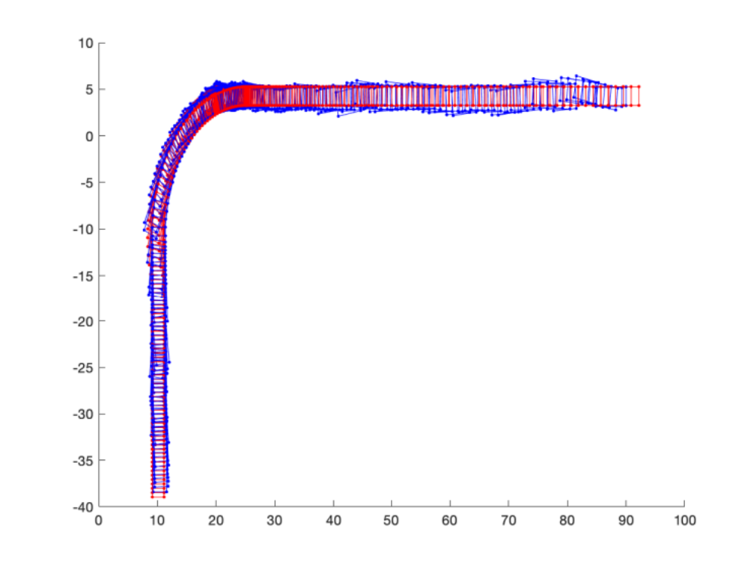

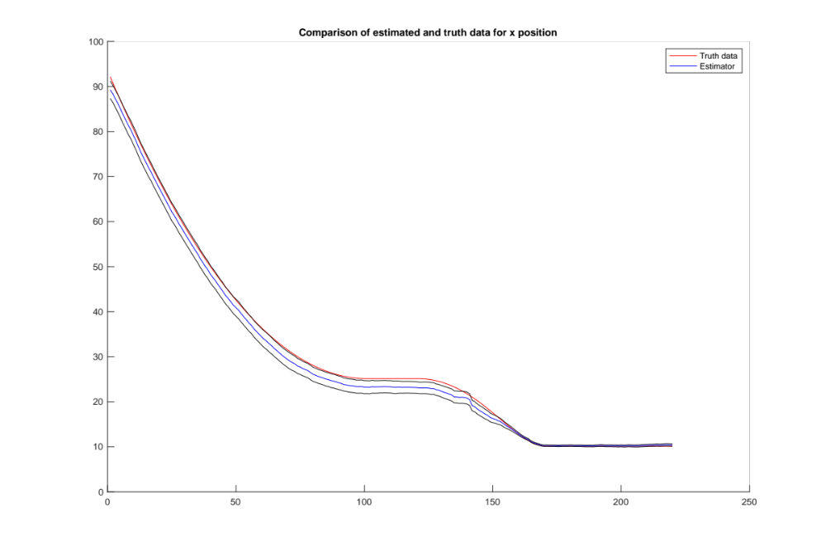

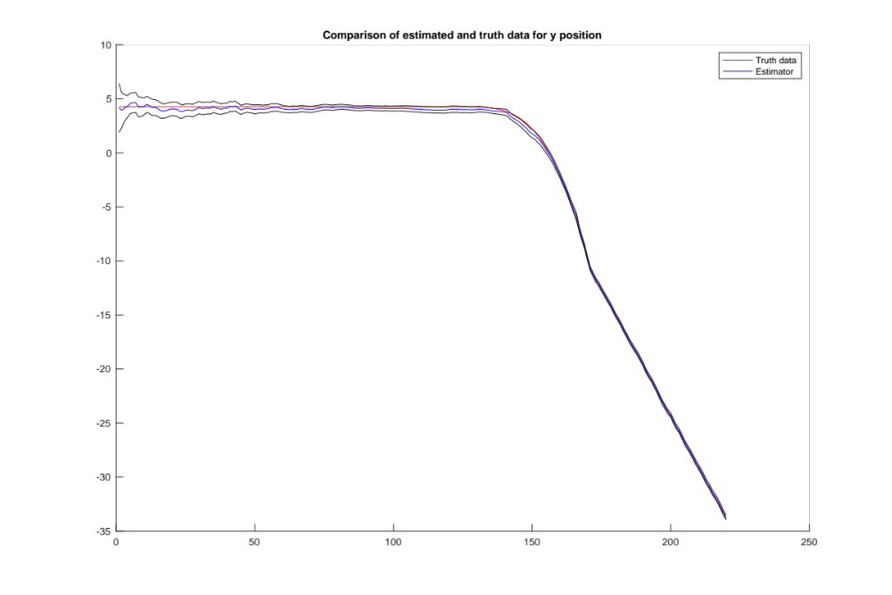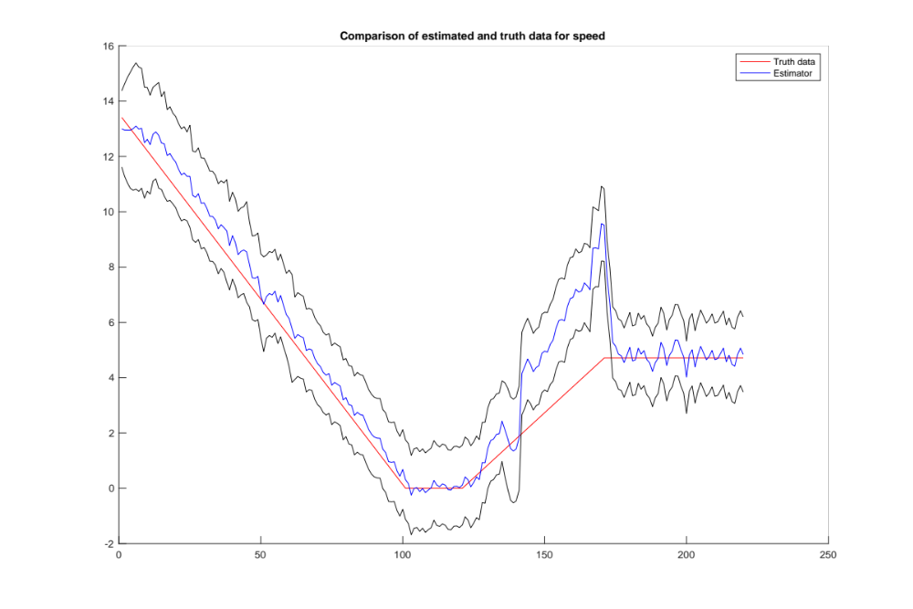
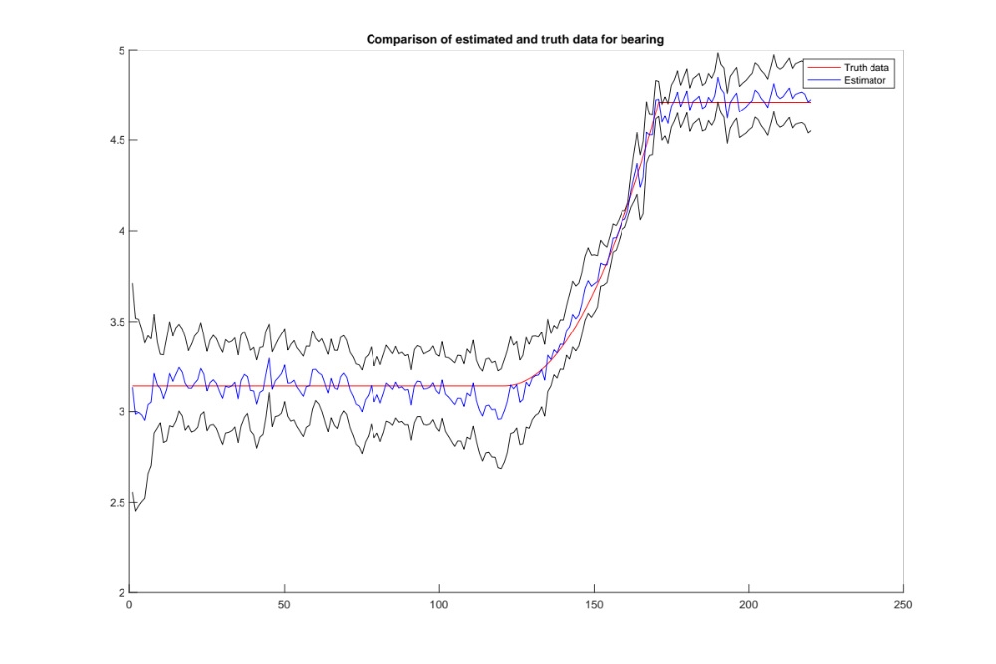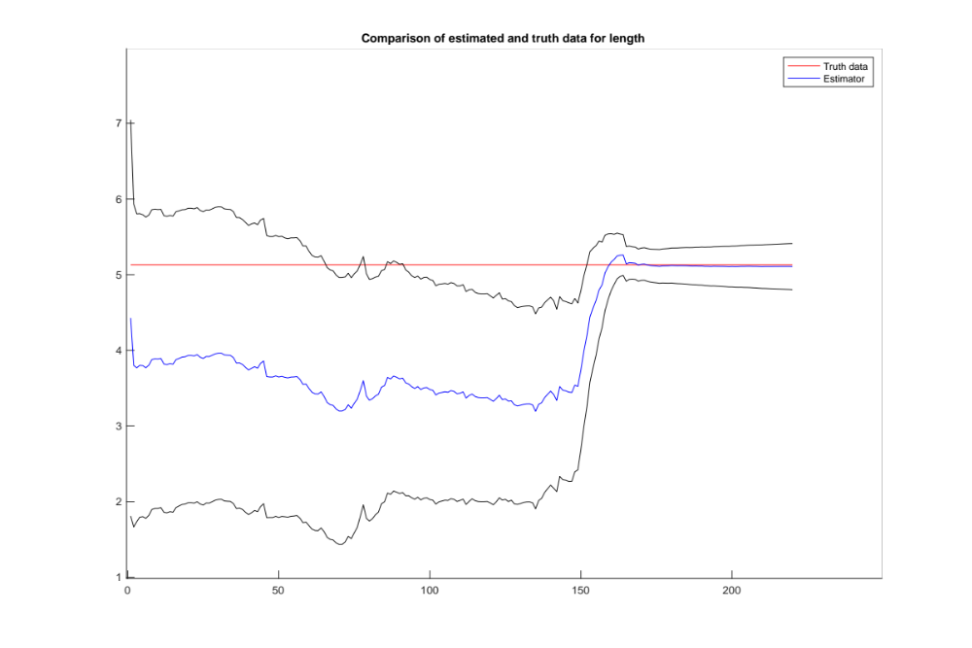

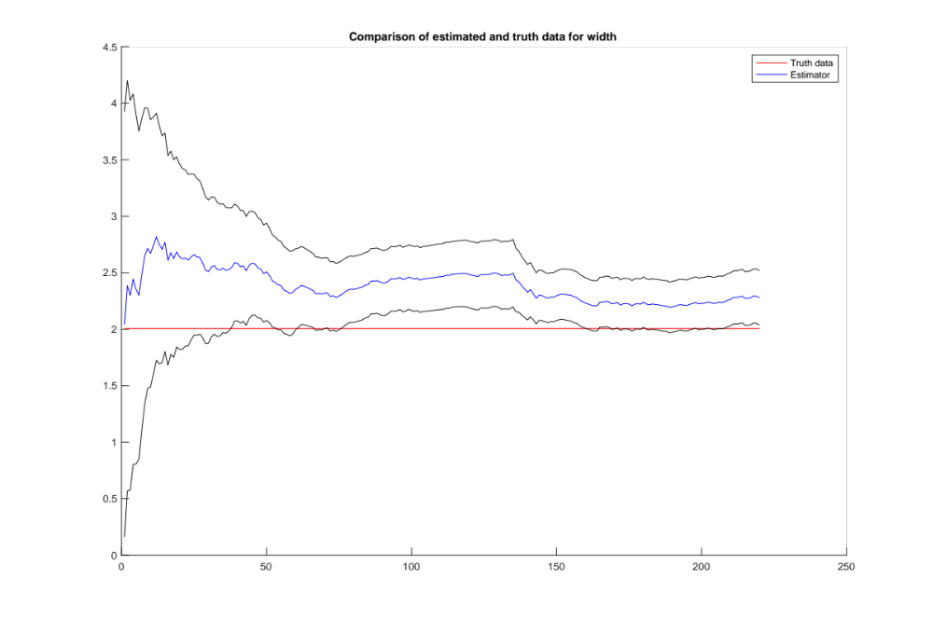
- What effects do the values of alpha, beta, and kappa have on the final state estimate?
Setting beta to be low, like 0, results in the estimates for the speed, bearing, length, and width to be very poor. It also causes some jumps in the x and y plots, but the final estimate of the state is ok in these two values.
Setting beta high, like 20, does not have a huge effect compared to the regular recommended values.
Setting alpha large, like 1, results in slightly worse x and y values along the way, but fairly decent estimates in general. The bearing especially seems to have larger error covariance with large alpha, even though the predictions are good.
Setting alpha small, like 1e-5, does not have a discernable effect. If alpha is very small, like 1e-7, then the matrix becomes not positive definite, so some square root version or higher precision is needed to use a smaller alpha.
Setting kappa large, to 10, produced pretty similar results, with some slight variation at the beginning in of the estimator values.
Making Kappa negative, such as -5, did not have much effect beyond slight distortions at the beginning.
- What do you notice about the state estimates, in particular length and width, as the target car performs its maneuvers?
When the car performs a maneuver, the length and width tend to suffer, although the error covariances do not change overly much. It seems that they are more affected by which direction the car is heading, so that the information in the measurement is more or less important to the estimated value. For example, at the beginning the length is very poorly estimated, but after the turn it is much better, due to the information that traveling with the length perpendicular to the lidar presented. The speed estimate also has a moment during the turn where it fairs badly, likely do to the lack of information in the measurements about the turn since the range stays constant and the min and max bearing do not change much as well.
- Why would it be difficult to implement this filter as an extended Kalman Filter?
This would be very difficult to implement in an EKF because the function which make up the measurement information are both highly non-linear, and not differentiable. For example, implementing a max and min function on the bearing reading is not a differentiable function, so creating a linearized version for an EKF would not be doable with the same setup. Also, the dynamic relating the bearing and range values to the x, y, speed, bearing, length, and width would be very cumbersome.
- Why did we choose to use the bearing-bearing-range measurement instead of some other measurement vector?
The use of bearing-bearing-range measurement has the advantage of being present immediately from the data, i.e. it takes very little processing to go from sensor data to filter input. It also provides some information to each of the state vectors, like the difference of the min and max bearing as a non-linear combination with the range relating to the length and width, the change in range relating to the speed, the x and y position being directly available from the range and bearing information. Then with the dynamics this allows for the possibility to estimate the whole state vector, while all of the information is usable without much extra processing. Plus the state dimensions are all non-linear with the measurement, so there is not some mixed linear vs non-linear state equations.
7) PS 8 IV Particle Filtering
%% PS SPF 4
% Bootstrap Particle Filter

clear all;
close all;

plotloc1 = [0, 1600, 900, 600];
plotloc2 = [900, 1600, 900, 600];
plotloc3 = [1800, 1600, 900, 600];
plotloc4 = [0, 300, 900, 600];
plotloc5 = [900, 300, 900, 600];
plotloc6 = [1800, 300, 900, 600];

plotting = 1;

dt = 0.1;
% noise for how far moved and how far turned
Q = diag([0.1, 5*pi/180])^2;

% turns, moves, listens to sonar, doesnt know which beacons are which
R = diag([1, 1, 1])^2;

% state is [x, y, theta]'
% theta is measured counter-clockwise from the positive x direction
nx = 3;
nu = 2;
nz = 3;
num_beacons = 5;

particles = 1000;
timesteps = 101;
part_set = zeros(3, particles);
old_parts = zeros(timesteps, 3, particles);

mhist = zeros(timesteps, particles);
% prop_part_set = zeros(size(part_set));
resample_index = 500;

xhat = zeros(nx, timesteps);
P = zeros(nx, nx, timesteps);

load('problem4data.mat');

xset = minx + (maxx-minx).*rand(particles, 1);
yset = miny+ (maxy-miny).*rand(particles, 1);

thetaset = 2*pi.*rand(particles, 1);

% equal weighting
weights = ones(particles, 1)./particles;
logwiprimek = zeros(particles, 1);

for k=1:particles
part_set(:, k) = [xset(k); yset(k); thetaset(k)];
end

for k=1:timesteps
uk = encoder(k).u;
vkminus1 = GaussGen(0, Q, nu, particles);
% propagate the particles forward

old_parts(k, :, :) = part_set(:, :);

for j=1:particles
part_set(:, j) = Propagate(part_set(:, j), uk, squeeze(vkminus1(:, j)));
end

zk = sonar(k).z;
% compute ranges to the three closest beacons for each particle
part_dist = zeros(num_beacons, particles);
% initialize so that it can be overwritten easily
nzbeacons = zeros(nz, particles);

for j=1:particles
for i=1:num_beacons
% use euclidean distance i.e. norm
part_dist(i, j) = norm(part_set(1:2, j) - beacons(i, :)');
end
nzbeacons(:, j) = mink(part_dist(:, j), nz);
logwiprimek(j) = -1/2*(zk - nzbeacons(:, j))'*inv(R)*(zk - nzbeacons(:, j)) + log(weights(j));
end

% update weights via log likelihood and max
maxlogwik = max(logwiprimek);
weights(:) = exp(logwiprimek(:) - maxlogwik);
weights(:) = weights./sum(weights);

Nhat = 1/(sum(weights.^2));
% figure;
% hold on;
if Nhat < resample_index
part_set_new = zeros(size(part_set));
% perform resampling
for g=1:particles
eta = 0.9998*rand(1) + 0.0001;
% Does not work if it needs every weight to reach eta
mm1 = 0;
sumwj = 0;
while sumwj<=eta
mm1 = mm1 + 1;
sumwj = sumwj + weights(mm1);
end
m = mm1;
part_set_new(:, g) = part_set(:, m);
mhist(k, g) = m;
% plot(g, m, 'x')
end
part_set = part_set_new;
weights = ones(particles, 1)./particles;
end

% estimate x and P
xhat(:, k) = zeros(nx, 1);
for j=1:particles
xhat(:, k) = xhat(:, k) + weights(j).*part_set(:, j);
end
P(:, :, k) = zeros(nz, nx);
for j=1:particles
P(:, :, k) = P(:, :, k) + weights(k)*(part_set(:, j) - xhat(:, k))*(part_set(:, j) - xhat(:, k))';
end

end

load('problem4truth.mat');

xtrue = zeros(nx, timesteps);
for t=1:timesteps
xtrue(:, t) = robot(t).x;
end

if plotting == 1
figure
hold on
plot(1:timesteps, xhat(1, :), 1:timesteps, xtrue(1, :));
plot(1:timesteps, xhat(1, :) + squeeze(sqrt(P(1, 1, :)))', 'k');
plot(1:timesteps, xhat(1, :) - squeeze(sqrt(P(1, 1, :)))', 'k');
title("Comparison of X(1)");
legend("Xhat(1)", "Xtrue(1)");
set(gcf, 'position', plotloc1);

figure
hold on
plot(1:timesteps, xhat(2, :), 1:timesteps, xtrue(2, :));
plot(1:timesteps, xhat(2, :) + squeeze(sqrt(P(2, 2, :)))', 'k');
plot(1:timesteps, xhat(2, :) - squeeze(sqrt(P(2, 2, :)))', 'k');
title("Comparison of X(2)");
legend("Xhat(2)", "Xtrue(2)");
set(gcf, 'position', plotloc2);

figure
hold on
plot(1:timesteps, xhat(3, :), 1:timesteps, xtrue(3, :));
plot(1:timesteps, xhat(3, :) + squeeze(sqrt(P(3, 3, :)))', 'k');
plot(1:timesteps, xhat(3, :) - squeeze(sqrt(P(3, 3, :)))', 'k');
title("Comparison of X(3)");
legend("Xhat(3)", "Xtrue(3)");
set(gcf, 'position', plotloc3);

figure
hold on
for i = 2:timesteps
plot(squeeze(old_parts(i, 1, :)), squeeze(old_parts(i, 2, :)), 'x')
end
for i = 2:timesteps
plot(xtrue(1, i), xtrue(2, i), '.k', 'MarkerSize', 20);
end
end

set(gcf, 'position', plotloc4);
xlim([0, 10]);
ylim([0, 10]);
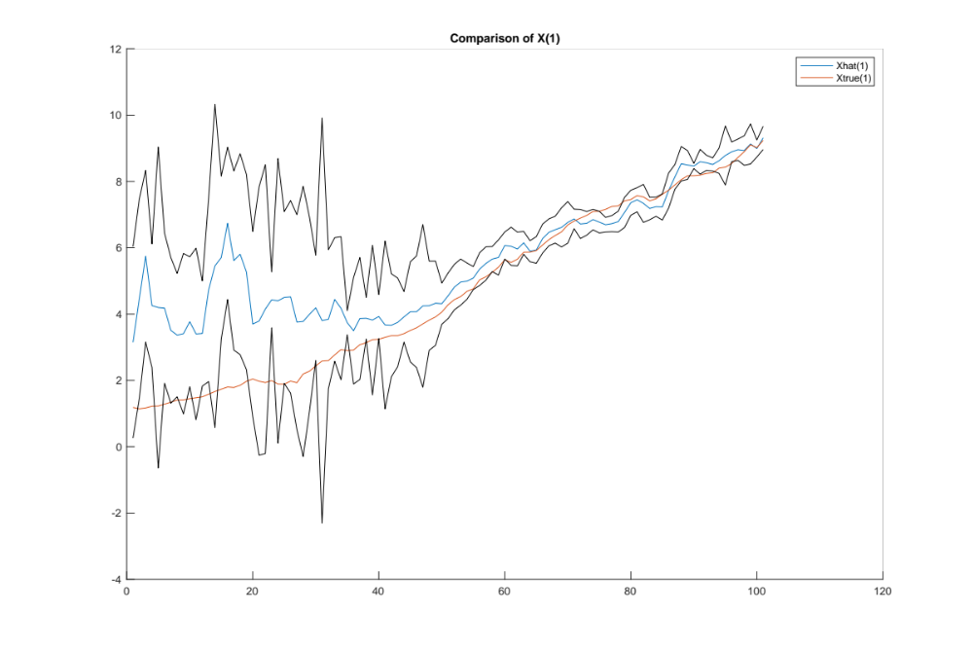
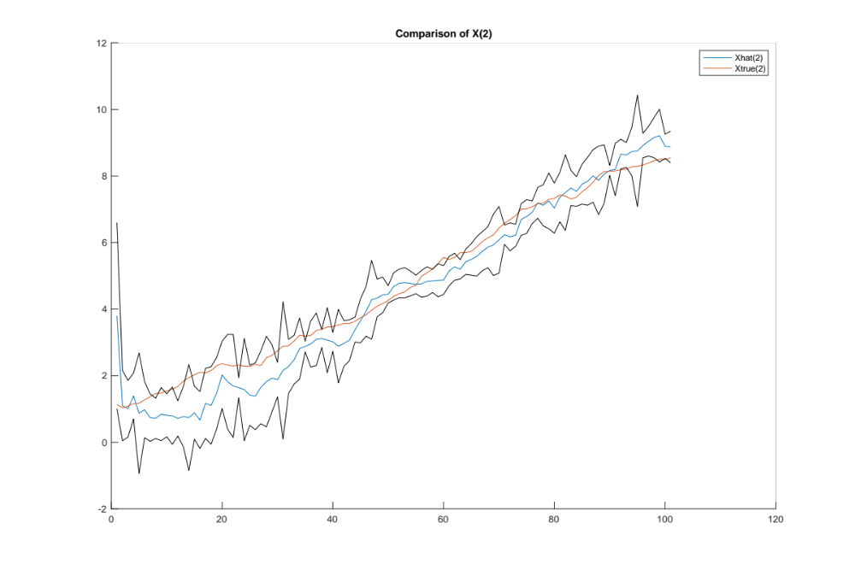

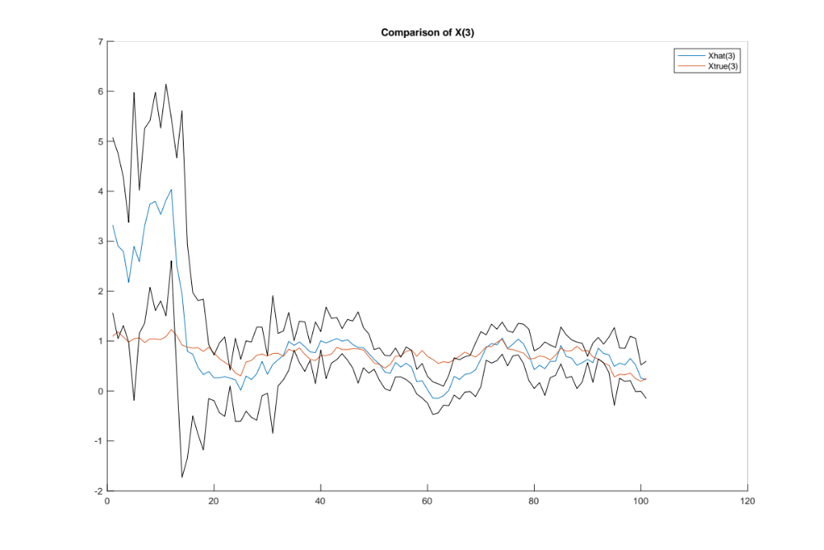
I also found the following plot useful for debugging/showing what is occurring. It shows the particles over all of the time steps, as well as the true data. If particles gather in incorrect areas, this is clear and suggests that they are at *possible*, but incorrect spots, due to the beacon distance measurements.
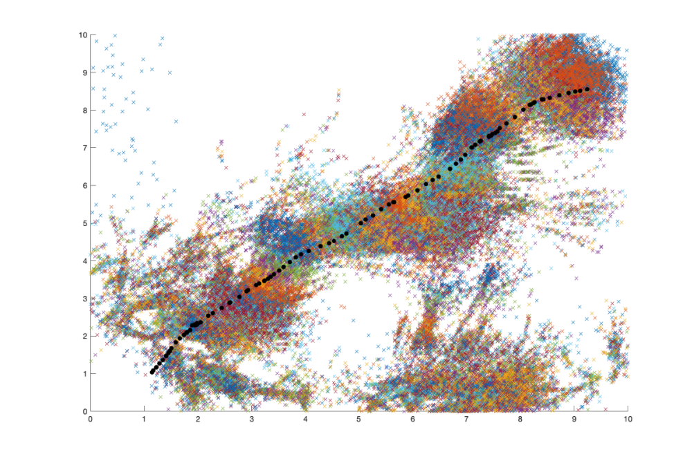
- Does the state estimate history change if you run the filter more than once? Why is that good or bad?
It does change and it is bad because it suggests the filter has some variance, which ideally would not occur so that the filter performs the same way each time. The number of particles corresponds to this variance, with higher particles resulting in lower variance, so one way around this is to use more particles, although this increases computational complexity.

- Why do clusters of particles sometimes persist in incorrect locations on the map?
I mentioned in the introduction to the graph above, but it is likely due to the way the measurement data is set up, with it just being the three closest beacons distances. This means that if the beacons are setup close enough, there are multiple spots with the same three distances, but to different beacons.

- Why would it be difficult to implement this filter as an extended Kalman Filter?
The hardest part would be linearizing the H, which is made of a min() function which is clearly not differentiable. To attempt to linearize this would obviously fail, especially with the top 3 of 5 making it even more non-differentiable. The overall non-linear single beacon case, which relies on the norm, would not be hard to make as an EKF, but adding the additional beacons and min() makes it difficult, and only using one beacon would yield a circle of possible points.

